SWELIM: Segregation of Waste and Elimination using Live Intelligent Machine
Author(s): Atish Kumar Halder¹, Ayush Kumar Singh², Kunal Bhattacharjee³, Rohit Singh⁴, Assistant Professor Anish Deb⁵, Debashis Sarkar⁶, Prosenjit Saha⁷, Roshan Kumar Singh⁸, Sayantan Bhattacharya⁹, P K Rao¹⁰.
Affiliation: Department of Mechanical Engineering, Asansol Engineering College, Asansol, West Bengal, India

Abstract - As cities expand quickly and consumption habits shift, trash production continues to rise, putting waste collection, processing, and disposal systems to the test. Much of this waste is the result of inefficient operations that waste resources, take longer than necessary, and use resources more than they need to, which affects the environment and the process. This essay talks about SWELIM, a conceptual model intended to recognize, classify, and get rid of different kinds of garbage in an organized way. SWELIM places a strong emphasis on grouping waste streams that are inefficient, cutting back on wasteful inputs like labour and storage, and recycling or reusing resources whenever feasible.
Index Terms—Waste segregation, waste elimination, sustainable waste management, resource optimization, circular economy.

INTRODUCTION
What is waste management? It is the process of collecting, transporting, treating, recycling, and disposing of waste from where it is generated to where it is finally released. It is a major social and environmental issue in the world. It arises from the use of products, industry, population growth, and urbanization.
The large number of people in India and the rapid growth of cities in the country make the situation worse. Indian cities generate 150,000 to 170,000 tons of waste every day. This is 62 to 170 million tons of waste annually. This may increase to 165 million tons per year by 2030 and is expected to increase further. However, only 20 to 54 percent of the waste is treated or processed, although 90 to 95 percent of the waste is collected. The remaining waste is generally left in landfills or open areas. This results in pollution and health problems. The waste is generally left in landfills or open areas, resulting in pollution and health problems.
Traditional waste management practices are done slowly and carefully. They require a lot of labour, time, and space, and biodegradable waste is often sent to landfills. Segregated waste makes it more difficult to implement the circular economy because of the increased costs of processing.
We should think positively about more than just sorting and disposing of things. By sorting early, grouping efficiently, and reusing or disposing of items that are not valuable, we can decrease resource usage and increase effectiveness for both people and the environment.
The proposed solution for these issues is named SWELIM (Segregation of Waste and Elimination using Live Intelligent Machine). The overall objectives of this project are to structure unorganized waste, reduce labour and inventory expenses, and design effective approaches for waste management, recycling, and reuse. The proposed solution, SWELIM, intends to make the current difficult and labour-intensive process of trash management a seamless operation that creates value by continuous improvement. SWELIM can be applied in various ways, such as in commercial, industrial, residential, and municipal areas. It is also prepared to implement emerging technologies such as AI-based sorting.
Using CAD software proves that SWELIM can perform well and expand. Technologists, architects, and designers apply computer-aided design (CAD) to design, modify, examine, and optimize 2D or 3D designs. They can design the separation chambers, conveyor system, devices, and building layout using 2D and 3D designs before constructing the SWELIM system. CAD software such as SolidWorks, AutoCAD, and Fusion 360 helps reduce design errors and expenses by simulating waste movement, analysing mechanical stress, and optimizing space utilization. Applying CAD software makes the SWELIM system more accurate, scalable, and adaptable to different locations, including cities, institutions, and residences.
The paper contains the following sections: problem statement, objectives, literature review, SWELIM concept and methodology, applications, expected outcomes, benefits, drawbacks, and future scope. Our main aim is about waste management in a proper manner. The conclusion emphasizes the importance of SWELIM in promoting environmentally friendly waste management.

PROBLEM STATEMENT
The reason why waste m
anagement is difficult is that waste is produced and just left in a pile in homes, businesses, and factories. When trash is disorganized, mixed together, and not managed in an organized way, it wastes resources, increases costs, and negatively impacts the environment and health when trash is disposed of. The current state of waste management is mostly reactive, where it concentrates on disposal and not on eliminating the non-value-adding steps in the process. Without an organized process to manage trash, there are health issues, increased costs, and recyclable and reusable materials are sent to landfills. In promoting environmentally friendly waste management. Thus, there is a critical and urgent need for a structured, scalable, and sustainable approach that minimizes resource dependency while maximizing outcomes. SWELIM is proposed to address this gap by providing a systematic methodology for waste identification, classification, and elimination

OBJECTIVE
The primary objective of the development of this waste management system is to provide a realistic and repeatable approach that enables communities, institutions, and small industries to manage solid waste in a smarter and more responsible way. The project aims to specifically meet the following objectives:

- To identify and separate the waste materials that have no useful service or very low recovery value at the point of generation, before they are mixed with other waste streams.
- To reduce manual labour, sorting time, and the area required for temporary waste storage by incorporating structured mechanical support and logical material flow at the earliest possible stage.
- To provide a clear and consistent approach to group waste based on its physical properties (size, shape, weight, flexibility, and magnetic properties) and realistic potential for reuse, material recycling, or disposal.
- To substantially increase the number of materials that can be recovered and sold or safely reused, while simultaneously reducing the total amount of waste sent to landfills or open dumps.
- Enhance the working environment of waste collectors by minimizing the need for frequent heavy lifting, reaching, and prolonged intensive manual sorting, thus improving safety and minimizing physical discomfort.
- Help create cleaner surroundings in residential areas, college campuses, markets, hostels, and small business districts by preventing scattered waste deposits and reducing unpleasant Odors and disease-carrying agents.
- Assist in developing a practical and efficient means of continuous measurement and improvement of the system so that local workers, student groups, or municipal staff can continuously improve the system without the need for outside experts for every change.
- Design a mechanical approach to waste management that is feasible to construct, maintain, and repair with tools, materials, and expertise readily available in smaller Indian cities and towns.

Collectively, the goals of the project are to change the nature of waste management from a tiring, expensive, and environmentally destructive activity to a more organized, resource-conserving, and truly beneficial activity for both people and the environment.

LITERATURE REVIEW
Because cities are developing, companies are rising, and people are becoming more concerned about the environment, researchers have long been interested in effective waste management. Numerous studies have shown that poor solid waste separation and disposal lead to resource waste, pollution, and health risks. The traditional method mostly relies on human separation, which takes a lot of time and effort and may pose health risks to the employees.

Some researchers have proposed automatic and semi-automatic techniques to overcome the drawbacks of conventional techniques. It has been demonstrated that machines based on centrifugal forces, air classification, and magnetic separation are more effective for separating heavy, light, and metal materials of solid waste. Pre-segregation at the source increases recycling significantly and minimizes the use of landfills, as proposed in fully automated systems. Moreover, these systems minimize direct human contact with waste, thus improving cleanliness and safety.

For garbage sorting, there are new developments involving robots and sensors. Garbage is categorized into metal, wet, and dry fractions using robotic arms and sensors such as inductive proximity, moisture, and infrared. Such concepts can be applied in smart city initiatives. However, most of these concepts rely heavily on hardware and are application-specific.

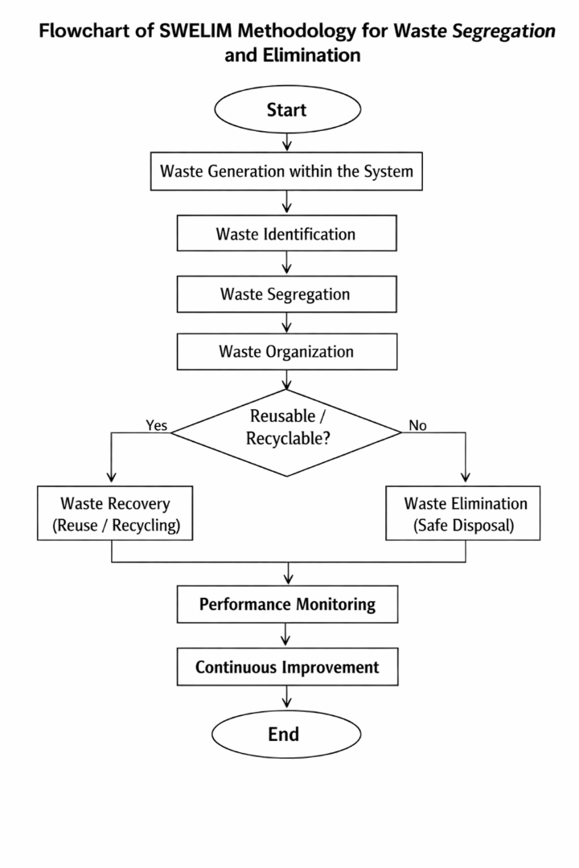
Real-time monitoring of the amount of trash, better routing, and better decision-making are made feasible by the increased use of the Internet of Things (IoT). IoT and smart waste management enable cities to become more efficient and cut costs. However, most research is focused on trash collection and appropriate sorting, and very little is focused on the removal of non-value-adding activities in the entire waste management process.

One of the major research gaps is the requirement for a unified approach to address waste management, resource utilization, and process optimization—not only waste separation. The SWELIM bridges this gap by presenting a comprehensive and scalable approach that integrates separation, elimination, and continuous improvement. It presents a holistic solution to waste management that seeks to strike a balance between sustainability and efficiency.

METHODOLOGY
SWELIM is a technique used for organizing and eliminating chaotic waste streams. The aim of SWELIM is to minimize additional personnel, time, and inventory.

The SWELIM process consists of the following steps:
- Waste Identification: Identify any items in the system that do not add value.
- Waste Segregation: Divide waste into separate categories based on appearance, recyclability, and disposal methods.
- Trash Management: Keep waste from piling up by maintaining consistent and manageable waste flows.
- Waste Elimination and Recovery: Eliminate waste according to category by recycling, reusing, or disposing of it.
- Performance Monitoring and Continuous Improvement: Monitor waste flows to ensure efficiency and adaptability.

- By taking these steps, waste management becomes proactive and organized, rather than reactive and disorganized.

SWELIM is a systematic process that focuses on organizing unorganized waste streams and eliminating inefficiencies. Waste comes in many forms and tends to accumulate without any systematic approach to eliminate it, making it expensive and labour-intensive. SWELIM addresses this issue by systematically evaluating waste, segregating it into specific groups, and identifying appropriate actions such as elimination, reuse, or recycling.

SWELIM minimizes excess manpower, time, and inventory, making it more efficient and effective in its operations, with a focus on sustainability and environmental stewardship.

APPLICATION
The SWELIM framework (Segregation of Waste and Elimination using Live Intelligent Machine) is intended to be flexible and scalable, allowing for easy implementation in various sectors with different waste generation patterns. The structured approach of the framework ensures effective waste management, focusing on sustainability and optimization.

In the residential and community setting, the SWELIM framework allows for systematic segregation and elimination of domestic waste at the source. By organizing waste and avoiding mixed disposal, the framework reduces the need for landfills and encourages sustainable recycling and reuse practices in the community.

In the industrial and manufacturing setting, the SWELIM framework helps to identify and eliminate non-value-adding activities related to material movement, process waste, and by-products. The framework helps organizations to optimize resource use, minimize excess inventory, and improve overall process efficiency in line with lean and sustainable manufacturing practices.

In commercial settings such as offices, shopping centres, and service organizations, the SWELIM framework helps to optimize waste generated from day-to-day business activities. Organized segregation and organization of waste reduce clutter, improve workplace cleanliness, and enable environmentally responsible waste disposal practices without disrupting business operations.

In educational institutions such as schools, colleges, and universities, the SWELIM framework can be applied as part of broader sustainability initiatives on campus. The framework enables systematic waste management, encourages environmental awareness among students and staff, and helps to create cleaner and healthier learning environments.

At a macro level, municipal waste management infrastructure can apply the SWELIM framework in conjunction with existing waste collection and recycling services. By optimizing waste organization and elimination at various points in the waste management chain, the SWELIM framework improves efficiency, reduces environmental degradation, and enables the development of cleaner and more sustainable cities.

EXPECTED OUTCOME
SWELIM is a simple framework that demonstrates its results in the way operations and systems function, rather than in traditional experiments. The results are measured by efficiency, improved processes, and a healthy environment in waste management.

One of the expected results is that there will be a reduced need for manual labour. This is achieved through improved waste handling and sorting. By sorting and handling less waste manually, SWELIM efficiently utilizes human resources without making operations less effective.

The framework will also reduce the time spent on sorting, handling, and disposing of waste. It provides a guideline on how to categorize waste and select rapid disposal or treatment methods, making the process faster and smoother.

SWELIM will ensure that waste does not accumulate by directing waste to the correct processing units on time. When less waste is left to accumulate, the facility operates effectively, using less storage space and preventing secondary pollution.

For resource recovery, the framework should increase recycling and reusing. By tracing waste streams at their point of origin and sorting them properly, more waste can be recovered. This promotes the circular economy and prevents the overuse of landfills.

From an environmental and health perspective, the efficient use of SWELIM should increase environmental cleanliness, prevent pollutants from spreading, and decrease health hazards. The framework uses appropriate waste classification and handling to prevent the release of toxic substances and to keep the waste area clean.

Finally, SWELIM promotes improved decision-making and governance through an appropriate and scalable waste classification system.
.

ADVANTAGES
- Systematic elimination of non-value-adding activities, resulting in better process flow and lean operations.
- Enhanced efficiency and sustainability, with processes aligned for optimal long-term performance and resource management.
- Minimized reliance on manual processing, facilitating more accurate automated processing and reduced human bottlenecks.
- Scalability to suit different sizes and industries, allowing the method to be expanded or contracted depending on requirements and applied to various industries.
- Facilitates circular economy concepts by making material recovery, reuse, and recycling easier.
- Minimizes manpower, time, and inventory needs through optimized processes and just-in-time management.
- Enhances efficiency in operations by removing waste, accelerating cycles, and optimizing resource utilization.
- Promotes material recycling and reuse, practicing closed-loop material management.
- Helps create a cleaner and healthier environment by reducing emissions, waste, and pollution.
- Aligns with sustainable development objectives by meeting environmental, social, and economic criteria.
- Scalable to suit different sizes and industries, ensuring applicability from small-scale projects to large-scale implementations

LIMITATIONS
Although the SWELIM framework is a structured, sustainable, and clear approach to waste segregation and elimination, it is important to note that there are some limitations to this framework. The initial implementation of the SWELIM framework may require a rearrangement of processes within an organization, changes in infrastructure, and training for employees. These activities may require a significant amount of time and resources, particularly when the waste management process is already set in place but inefficient.

The success of the framework is largely dependent on the accuracy of waste identification and classification. Inefficient segregation, handling, or a lack of user awareness may affect the performance of the system and result in suboptimal outcomes. Therefore, it is important to have guidelines in place and ensure that users comply with them.

Additionally, the SWELIM framework requires continuous monitoring and evaluation to ensure that its long-term success is maintained. If this is not done, the waste streams may become disorganized, and the framework may not achieve its intended goals.

FUTURE SCOPE
The following steps are part of the SWELIM process:

• Waste Identification: Finding resources and actions in a system that don't create value.
Sorting garbage into distinct groups based on physical characteristics, recyclable materials, and disposal requirements is known as waste segregation.
• trash Organization: To prevent accumulation and inefficiencies, separate trash should be arranged into manageable streams.

• trash Elimination and Recovery: Depending on the particular group, trash can be eliminated by recycling, reuse, or elimination.

• Performance Monitoring and Continuous Improvement: To preserve effectiveness and flexibility, waste streams must be continuously assessed.
• By following this methodical procedure, waste management is transformed from a reactive to a proactive and optimized system.

This guarantees that garbage is sorted consistently and dependably. By adding spinning separation technologies like dynamic separators and centrifugal classifiers, the SWELIM architecture can be enhanced. These technologies make it possible to consistently and effectively segregate mixed garbage into several streams. Different forces act on materials by altering the rotation speed. Lighter materials stay in the middle, while heavier materials are forced to the outside. This makes it possible to separate materials effectively without the need for chemicals or manual labour. Additionally, centrifugal technology helps stabilize waste material size and reduce moisture, especially for organic and semi-solid waste.

CONCLUSION
In summary, SWELIM is a scalable and future-oriented approach to waste management. It is ready to address the sustainability challenges of today and those that may arise in the future. This is because it leverages the power of complex systems working together, data-driven decision-making, and resilience throughout the entire plan. Another advantage is the use of Computer-Aided Design (CAD), which makes SWELIM more feasible by providing precise models of the system, improved layout designs, comprehensive process modeling, and effective infrastructure development. Through CAD design and analysis, the processes involved in waste management can be designed more precisely, efficiently, and effectively. This results in optimizing resource use and aligning well with digital, cyber-physical, and Industry 4.0 systems.

REFERENCE
[1] World Bank, What a Waste 2.0: A Global Snapshot of Solid Waste Management to 2050. Washington, DC, USA: World Bank, 2018.
[2] Central Pollution Control Board (CPCB), Annual Report on Municipal Solid Waste Management in India. New Delhi, India: Ministry of Environment, Forest and Climate Change, Government of India, 2020.
[3] N. Mukherjee, Solid Waste Management. Mumbai, India: Oxford University Press, 2010.
[4] H. K. Prashanth, A. Ballur, D. Saidapur, M. Ranjanagi, and R. Nimbalkar,
“Design, fabrication and analysis of fully automatic solid waste segregation system,”
International Journal of Innovative Science and Research Technology, vol. 3, no. 4, pp. 344–347, Apr. 2018.
[5] B. S. Susha, R. M. Shanbog, S. Hussain, H. K. Shreyas, and S. Shreyas,
“Automatic segregation of waste using robotic arm,”
International Journal of Creative Research Thoughts (IJCRT), vol. 9, no. 7, pp. f32–f35, Jul. 2021.
[6] M. O. Rahman, M. A. Hannan, E. Scavino, A. Hussain, and H. Basri,
“Development of an intelligent computer vision system for automatic recyclable waste sorting,”
Waste Management, vol. 34, no. 11, pp. 2224–2234, Nov. 2014.
[7] M. J. Rogoff, R. E. Ross, J. L. Lilyquist, and J. L. Wood,
“Automated waste collection systems and their application in urban environments,”
Journal of Solid Waste Technology and Management, vol. 33, no. 2, pp. 78–86, 2007.
[8] D. Kaliampakos and A. Benardos,
“Underground solutions for urban waste management,”
Waste Management, vol. 28, no. 8, pp. 1399–1413, Aug. 2008.
[9] U.S. Environmental Protection Agency,
Managing Your Hazardous Waste: A Guide for Small Businesses.
Washington, DC, USA: EPA, 2016.
[10] J. L. Garcia, R. M. Romero, and P. J. Perez,
“Process optimization and waste elimination in sustainable manufacturing systems,”
Journal of Cleaner Production, vol. 172, pp. 293–305, 2018.

